THE BATTLE OF BENFLEET – SCRIPT (for
PICTURE 1 – OPENING SCREEN
There has always been a great deal of mystery about the Battle of Benfleet and this is probably why, in spite of its importance, so few people have written about it.

From the time when the remains of the Danish great army left the island on the River Colne in Buckinghamshire, up to the day the fortified camp at Benfleet was destroyed, we have little written information except the account in the Anglo-Saxon Chronicle.

Before we look at the history here, perhaps we should reflect back to the way Britain was divided and ruled before the Viking period and then, Danelaw, or that which the Vikings ruled over.

PICTURE 2 - Angles, Saxons and Jutes around 600AD.

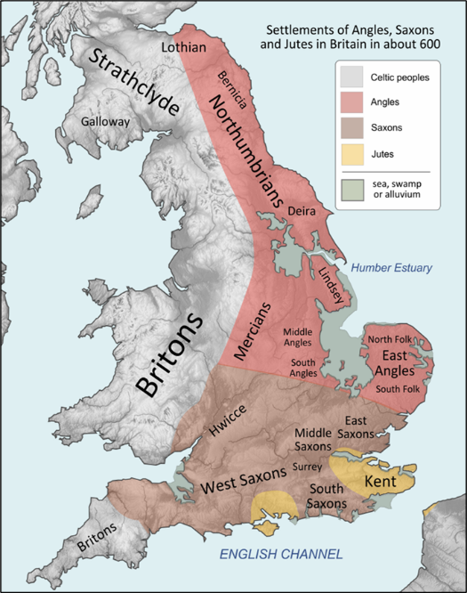
Roman Lindum became Lincoln in the Kingdom of Lindsey.

The Kingdom of Deira from around 71AD to 470AD evolved into Yorkshire.

Bernicia established in the sixth century covered South East Scotland and North East England.

East Saxons - Essex.
South Saxons - Sussex.
Middle Saxons - Middlesex

And of course East Angles with North Folk and South Folk.

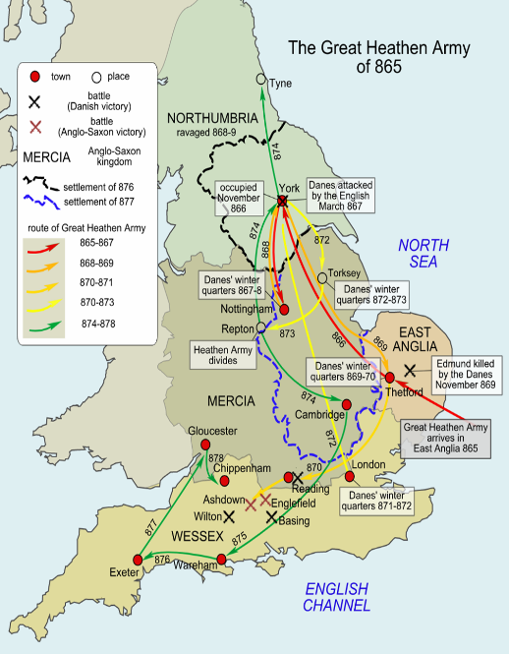
PICTURE 3 – The Great Heathen Army of 865AD.

The version which contains the account, written by Ethelweard, great grandson of King Alfred’s brother Ethelred, some seventy years after the event, but is generally accepted as true.

Beyond this, we have to rely on what the historians call “intelligent conjecture” that is, on deduction based on what we know about the state of affairs at the time.

PICTURE 4 – The Boundary of Danelaw.
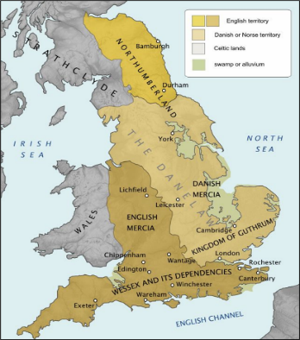
The Area eventually settled by the Vikings.

It formed a boundary between Anglo-Saxon England and Viking England.

It was formed in 880AD after a treaty between King Alfred and King Guthram.

PICTURE 5 – Haesten.
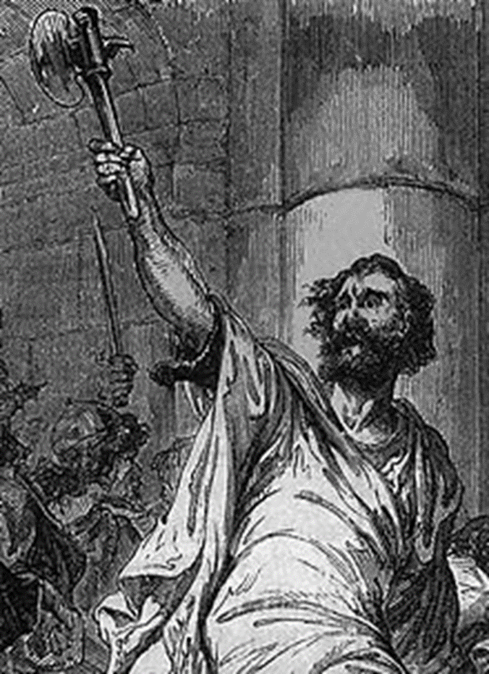
Haesten and the Danes had set out on a campaign hoping for plunder and eventually to conquer all England, but by this time they had received a number of severe shocks.

They had not been able to join up their two armies in Kent; the main army had lost a battle at Farnham and had been driven headlong across the Thames and then surrounded by the Saxons under Edward and Ethelred.

Those who had got back to Benfleet were probably only a fraction of the original number, some of whom had been killed and others who deserted to join their friends elsewhere in the Danelaw.

They would have reached Benfleet weary with fighting and marching, having lost most of their equipment and when they arrived at the fortification they could have found little to encourage them, for two further events happened.

Haesten, in need of supplies, had taken off his force on a plundering expedition, leaving Benfleet manned by a garrison to guard the women and children, including his own.

The two hundred ships which had transported the army from France had moved from Appledore to Benfleet but then left for a better haven in the waters around Mersea Island, leaving at Benfleet around eighty ships belonging to Haesten.

PICTURE 6 – Haesten’s Benfleet Camp.
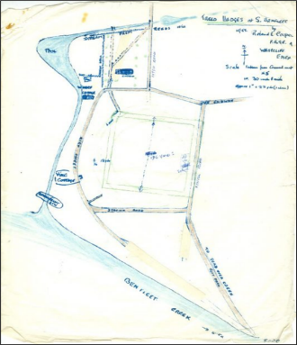
The 1955 sketch map of where the camp might have been.

The camp lies on the open square of sloping ground (now the car park) above Vine Cottage in the High Street.

It is about a hundred yards square but its ditches have long been filled in over the centuries.

The Latin Chronicle of Matthew of Westminster in the year 1326 speaks of it as being “strengthened by deep and broad trenches” which implies something more than a temporary fort.

All through the campaign the English had done well, one victory being followed rapidly by another. The only real reverse was that of allowing the remnants of the Danish force to escape to Benfleet.

PICTURE 7 – Alfred the Great (848 – 899).
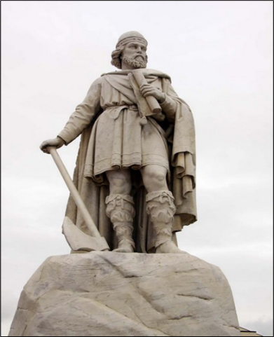
Alfred was King of the West Saxons from 871 to c. 886 and King of the Anglo-Saxons from c. 886 to 899.

He was the youngest son of King Æthelwulf, who died when Alfred was young. Three of Alfred's brothers, Æthelbald, Æthelberht and Æthelred, reigned in turn before him.

After ascending the throne, Alfred spent several years fighting Viking invasions.

He won a decisive victory in the Battle of Edington in 878 and made an agreement with the Vikings, creating what was known as the Danelaw in the North of England.

Alfred also oversaw the conversion of Viking leader Guthrum to Christianity. He defended his kingdom against the Viking attempt at conquest, becoming the dominant ruler.

He had a reputation as a learned and merciful man of a gracious and level-headed nature who encouraged education, improving the legal system and military structure and people's quality of life. He was given the epithet "the Great" in the 16th century.

Alfred himself went to the west country, but left behind two commanders, one being his son Edward, who was equal in ability and he, with his kinsman Ethelred of Mercia and the English army, gathered their strength in London and were joined there by Londoner’s.

Some were merchants son’s, others were from the English noble gentry and all were keen to meet the enemy. The morale of the English force was high, they were at the peak of their strength and fortunes, whilst the Danish survivors were the opposite in readiness.

London to Benfleet was a distance of more than thirty miles. At that time, apart from the well-trodden road through Ilford, Romford, Brentwood, Billericay and Wickford, the country was difficult to cross because of thick forest and extensive riverside marshland.
This in itself, however, was rather to the good, for if the Benfleet fortification were to be taken, it would have to be by surprise attack. One could not imagine the English army coming openly along the only road which at that time existed.

In Essex, his son Edward, had ample opportunity to show his own skill. There was good cover in the woods around North Benfleet, Hadleigh and Thundersley and in the desolate fens along the river Thames.

It is true to say, the English would be crossing land which belonged to the Danes, but that meant little, for it was not in any way garrisoned by them.

The Danes, who appeared not to have ‘scouted’, were busy with their own affairs and who, in their encampment at Benfleet, may not have even known the enemy was ‘at hand.’

Once contact had been made, it is again possible that, before the Danes had time to recover from the surprise, their fortified camp could have been stormed, their ships taken or burned and their garrison captured, slain or driven out of the camp.

At the time of the battle, Haesten was about sixty years of age and nearing the end of his adventurous career. During the ten years before the Benfleet campaign he had lived mainly in France and his forces had wintered each year near the mouth of the river Loire.

He may, at that time already have picked out Benfleet as a future base of operations, for we are told that the campaign of 892, when both armies came to England, had been planned beforehand.

One imagines Benfleet to have had some years before 893, a small Danish community and to have acted as a retreat and ‘repair shop’ dominated by the fort which Haesten had built.

There were woods, water and everything else needed for such a purpose. The Hadleigh Ray isolating it from the Thames made it much easier to defend from attack by water.

The Danes being seafarers, had to find places for their strongholds where they could easily reach their ships. They preferred a spit of higher land almost surrounded by water if they could find one; but if not, they would protect themselves by digging ditches.

Benfleet had every advantage. The high spit of land was only accessible by the narrow Hadleigh Ray and was surrounded on all sides but one by water, for the creek in those days had not been silted up or shaped by the hand of man.
It was much wider than it is now and the waterway would extend well up the valley beyond the church, below what is now Essex way. The creek where the roadway passes over it could have been as much as twenty feet wide.

The creek at the base, much wider and deeper, was crowned with ships whose gilded serpents at the stern and gay figureheads at the bow, were too familiar to the Saxons in their admiration.
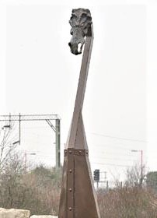
PICTURE 8 – The Viking Longboat at Benfleet.

Where Longboat ashes were also found in Ferry Road.

PICTURE 9 – Hadleigh (Hadley) and Thundersely Woods.
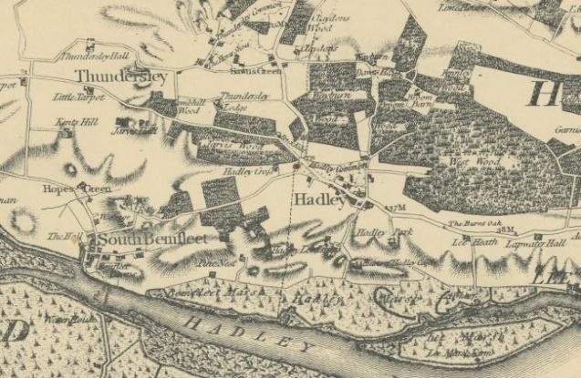
Settlements in the hills have names ending in leah, an Anglo-Saxon word meaning ‘clearing‘.

It is therefore likely that villages such as Hadleigh, Thundersley, Rayleigh and Hockley (then much smaller than they are today) were established in clearings in the wildwood.

A few Saxon names for some of these woods survive to appear on old maps and Horseley wood (part of Hadleigh Great Wood), Goldingsley (part of Belfairs Wood) and Tilehurst (the old name for Tile Wood — hyrst means a wood on a hill) are all close to Pound Wood.

It is generally agreed this was the area on which the Danish fort stood, but where were the ramparts and ditch which protected it on its fourth or eastern side? It is believed that these ran along the line now traced by Grosvenor Road, then across St. Mary’s Road at the top of the hill and down the southern side of the incline to the Ray.

This seems probable, for as we stand in St. Mary’s Road which runs along the ridge, we see quite a slope on two sides where the top of Grosvenor Road meets it. That on the western or fort side is steeper.

One may be mistaken, but on an aerial survey there appears to be a distinct line continuing as a kind of crop mark from the top of Grosvenor Road down the slope to the Ray, just beyond the point where the modern Ferry Road turns right to cross the bridge to Canvey.
Imagine then, this whole area enclosed, on the water side by a strong stockade and on the landward side by ditch, rampart and stockade and this gives some idea as to what the fort would have been like.

PICTURE 10 – South Benfleet
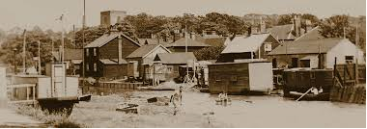
Another author writing in 1885 says that there were in his day quite enough traces around the churchyard to mark out one corner of the Danish fortress.

“The fortress at Beamfleote had ‘ere this been constructed by Haesten and he was at the same time gone out to plunder and the great army was therein”.

Then they came and put the army to flight and stormed the fortress and took all that was within it as well as the women and children also and brought the whole to London and Mancester (Bradwell) and they brought the wife of Haesten and his two sons to the King.”

In 1855 when the London, Tilbury and Southend railway line was being constructed, the navvies were driving piles for the bridge and preparing the track when they unearthed a remarkable discovery.

Here they came upon fragments of ship’s timbers, charred black with fire. They had laid buried for almost a thousand years and about them lay quantities of human bones - the remains of those who fell in the assault.

How did Edward and his brother-in-law storm this fort? It is unlikely that the Danes came out of their stronghold to fight on level ground for only the levels near at hand were flooded twice a day by the tide.

The fort was certainly stormed but the truth about this mysterious battle may never be fully known though many legends have grown up around it.

One of these concerns a fragment of skin long believed to be that of a Dane found beneath the stud nails of the church door. This kind of story is not uncommon in Essex.

In Elizabethan days churchwardens gave a shilling for every badger caught and killed and the skins were often nailed to church doors as evidence that the vermin had been destroyed. This custom may have something to do with the legend.

The Danes who survived the slaughter fled and set up another fortified camp at Shoebury and here the remnants of the great army gathered together. Shoebury being more distant did not present the same threat to London as Benfleet had done.

The action at Benfleet was decisive because at the end of thirty years of war it marked “the beginning of the end” for the Danes. Alfred died five years later but the pressure on the enemy was kept up by his son Edward from London and by his son-in-law Ethelred from the west midlands.

In 991 Essex saw another battle when the English Ealdorman (or Earl) Brithtnoth met the Danes at Maldon. Challenged to a fight on equal terms he allowed them to cross from Northey Island to the mainland and here the defeated and slew him. The Battle of Maldon is the subject of one of our earliest English poems.

In 1016 another decisive battle was fought at Ashingdon between Ethelred’s son Edmund (known as Edmund Ironside) and Canute (Knut), son of Sweyn.

Canute had been making a raid deep into the eastern counties and was returning towards the River Crouch where his ships were anchored when Edward caught up with him, forcing him to turn and fight on the level ground between Ashingdon and Canewdon.

The English might well have won this hard-fought battle had not Edmund’s own brother-in-law Edric Streona fled at the second charge and brought ruin on his own countrymen.

Edmund survived the defeat and agreed to share England with Canute, with Edward taking much of Wessex and Canute the rest of the country. Within a month of the battle, however, Edmund died and Canute became the first Danish King of England.

PUCTURE 11 – A RETROSPECT OF TIME:

666 A.D. Probable date of the foundation of Barking Abbey
870 A.D. Barking Abbey destroyed by the Danes.
930 A.D. Probable date of the rebuilding of Barking Abbey
940 A.D. First mention of Thundersley in records.
991 A.D. Defeat of Brithtnoth at Maldon.
1000 A.D. Hadleigh mentioned as belonging to St. Paul’s.
1016 A.D. Battle of Ashingdon and Canute King of England.
1042 A.D. Accession of Edward the Confessor.
1066 A.D. Battle of Hastings.
Death of Edward the Confessor. Accession of Harold and Battle of Stamford Bridge.
1067 A.D. South Benfleet Manor given to Westminster Abbey.
1086 A.D. The Domesday Survey began.

End.

